Food Distribution System

Software Design patterns Project

**Hania Wael Abdelkhalek 20P4821**

**Jumana Yasser 20P8421**

**Mohamed Elsayed 1901757**

**Ahmed Hesham Mohamed 19p8052**

Submitted to:  
**Dr. Ayman Ezzat**

**GitHub Repo:** [**https://github.com/AhmedHeshamSakr/Food-Distribution-System-Using-DP.git**](https://github.com/AhmedHeshamSakr/Food-Distribution-System-Using-DP.git)

**Attached Project Files:** [**https://drive.google.com/drive/folders/19ZjFJmQKa-nKckeZba99GwBbf1M8WG4t?usp=sharing**](https://drive.google.com/drive/folders/19ZjFJmQKa-nKckeZba99GwBbf1M8WG4t?usp=sharing)

Contents

1. Strategy Design Pattern 2

1.1 Strategy Interface 2

1.2 Concrete Strategies 2

1.1 Strategy Interface 4

1.2 Concrete Strategies 4

5

2. Observer 6

3. Decorator 8

3.1 Component 8

3.2 Concrete Component 9

3.3 Base Decorator 10

3.4 Concrete Decorators 11

4. Factory 12

4.1 Product 12

4.2 Concrete Products 13

5. SingleTon 16

6. Command 17

7. Adaptersss 20

8. Façade 21

9. Template 24

9.1 Abstract Class 24

9.2 Concrete Classes 25

10. Iterator 26

11. State 28

12. Proxy (Virtual Proxy Design Pattern) 29

13. MVC 31

# Strategy Design Pattern

#Payment

### Strategy Interface

### 1.2 Concrete Strategies

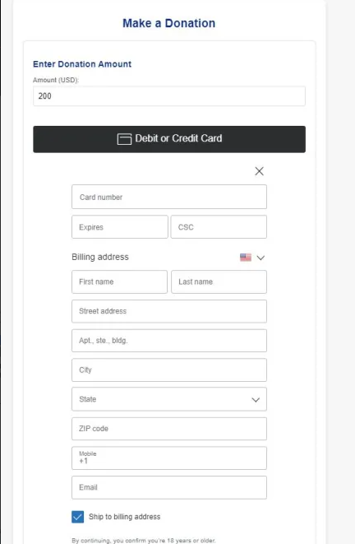

#Login

### Strategy Interface

### Concrete Strategies

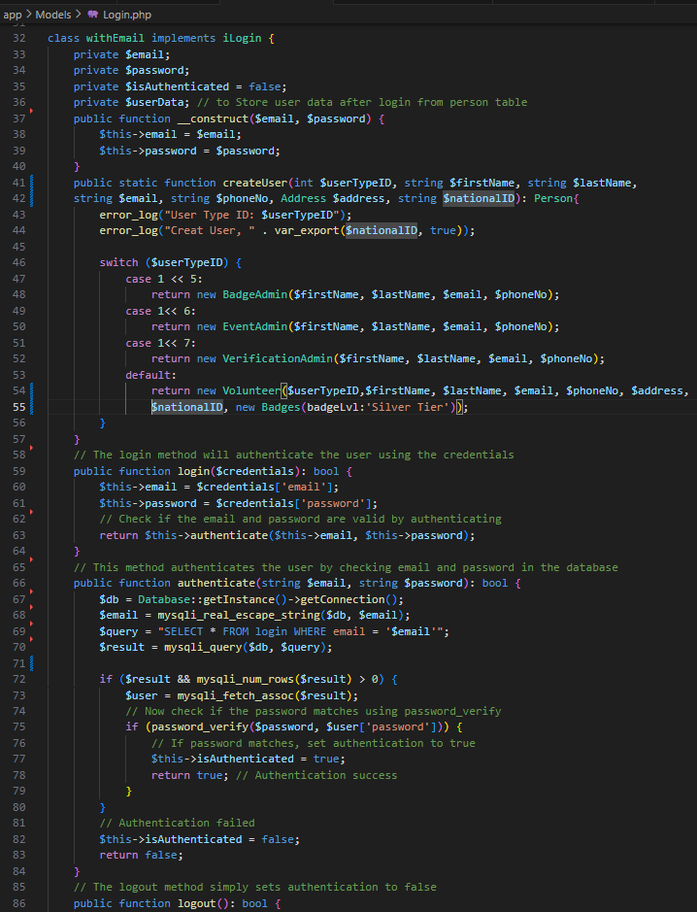

# Observer

* 1. Subscriber Interface

* 1. Subscriber

* 1. Publisher Interface

* 1. Publisher

# Decorator

### Component

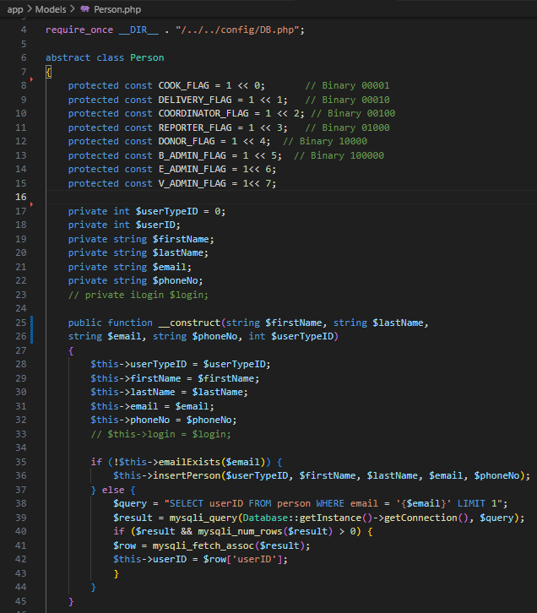

### Concrete Component

### Base Decorator

### A screen shot of a computer program Description automatically generatedA screenshot of a computer program Description automatically generatedConcrete Decorators

### 

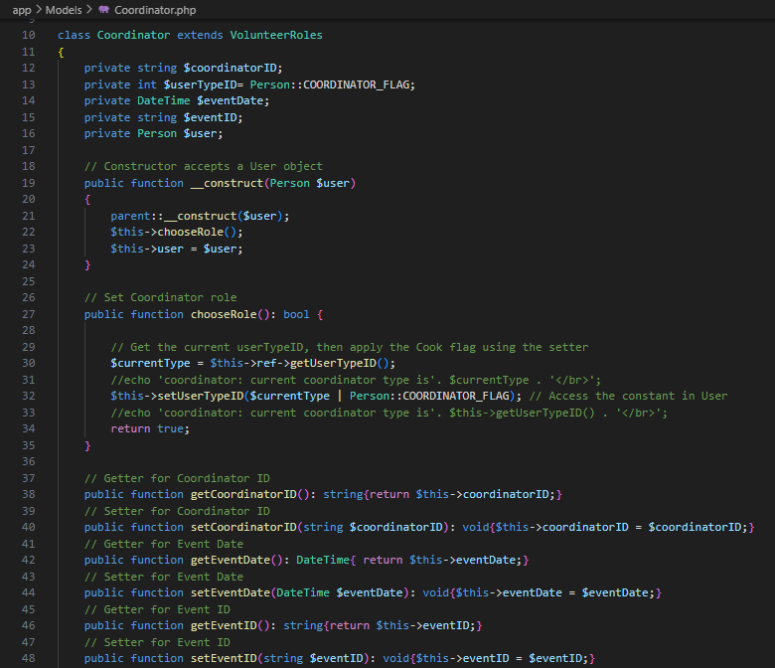

# A screen shot of a computer program Description automatically generatedFactory

### A screen shot of a computer program Description automatically generatedProduct

### A screen shot of a computer program Description automatically generatedConcrete Products

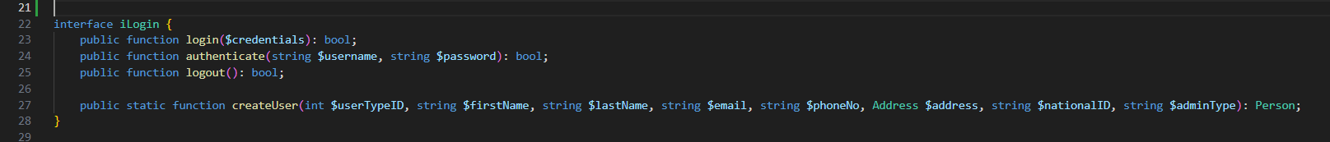4.3 Interface Creator

* 1. A computer screen shot of text

     Description automatically generatedConcrete Creator

Where type of class registered to is instantiated.

# A screenshot of a computer program Description automatically generatedSingleTon

# Command

* 1. Command Interface

* 1. Recievers

* 1. A computer screen shot of a program code

     Description automatically generatedA screen shot of a computer program

     Description automatically generatedConcrete Commands

6.4. Invoker

# A screen shot of a computer code Description automatically generatedAdaptersss

# Façade

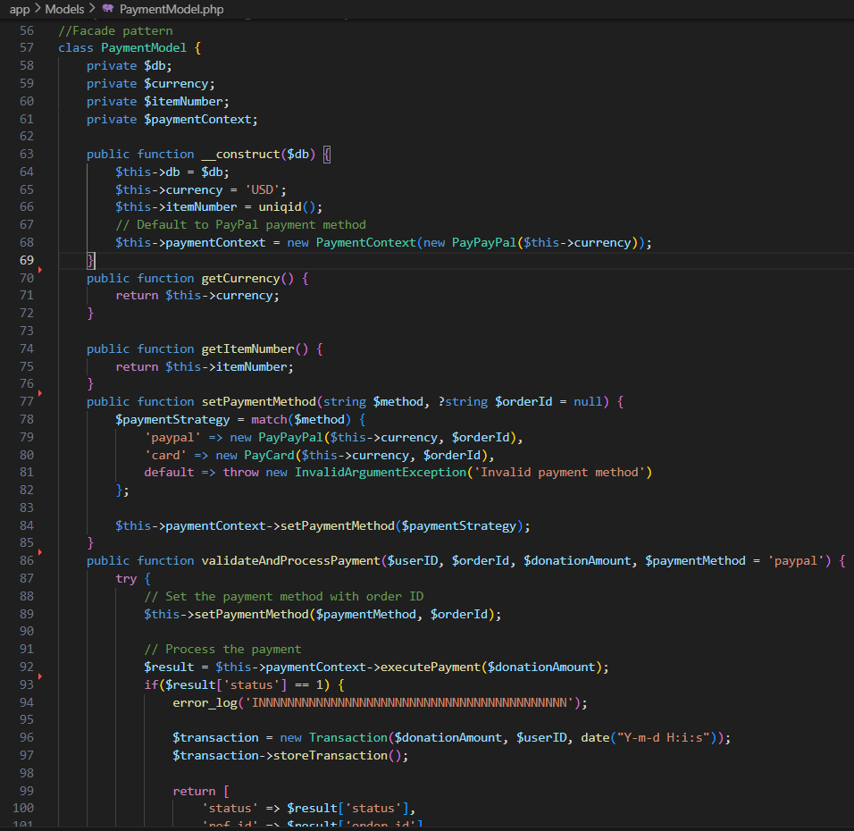8.1. Facade

8.2 Subsystems

# Template

### Abstract Class

### Concrete Classes

# Iterator

* 1. Iterator Interface

* 1. A black background with white text

     Description automatically generatedIteratable Interface
  2. A computer screen shot of a program

     Description automatically generated Concrete Iterators

* 1. 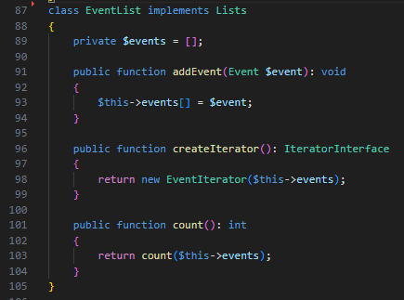A computer screen shot of text

     Description automatically generatedConcrete Collections

# State

* 1. State Interface

* 1. Concrete States

# Proxy (Virtual Proxy Design Pattern)

12.1 Service Interface

12.2 Service

12.3 Proxy

# A screenshot of a computer Description automatically generatedMVC

